|  |
| --- |
| C:\Users\Guleria\Google Drive\Logo.png |
| Battle Truck |
| Saving the Soldiers |
| Version #1.1  All work Copyright © 2012 by G Studio.  All rights reserved. |
| **Vishal Guleria AND Vinay Bhardwaj** |
|  |

|  |
| --- |
| March 10, 2016 |

**Table of Contents**

Table of Contents

GitHub Link 3

Game Overview 3

Camera 3

Controls 3

Interface Sketch 4

Menu and Screen Descriptions 5

Game World 5

Levels 5

Characters/Objects 5

Military Truck 5

Non-player Characters 5

Barrie Wall 5

Enemies 5

Mines 5

Soldiers 6

Scoring 6

Lives 6

Scores 6

**Version History**

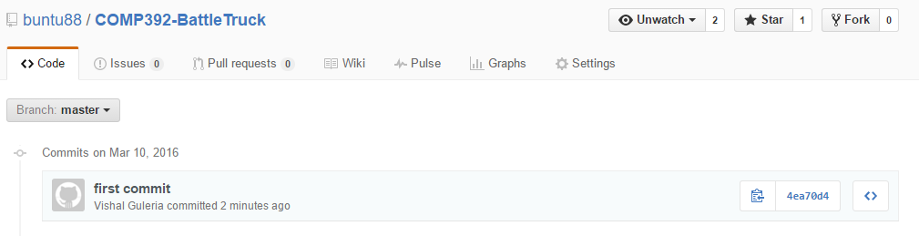

# GitHub Link

<https://github.com/buntu88/COMP392-BattleTruck.git>

# Game Overview

This application is a 3D first person game designed using ThreeJS and with the help of Blender. In this game, fundamental article is a Truck in a battlefield to bring back abandoned soldiers. Truck has to go through some obstructions and challenge to achieve its goal. Truck have basic first person control like moving forward, backward etc.

# Camera

This is 3D game, so orthographic first person view is used for the camera.

# Controls

In this diversion, Up, Right, Left and Down key or W, A, D and S are the principle controls to make it easy to understand. The diverse catches are play again catch.

**Play Again**: - After the game is over, player has an alternative to play the game again by tapping on play again catch symbol.

# Interface Sketch

Main Screen

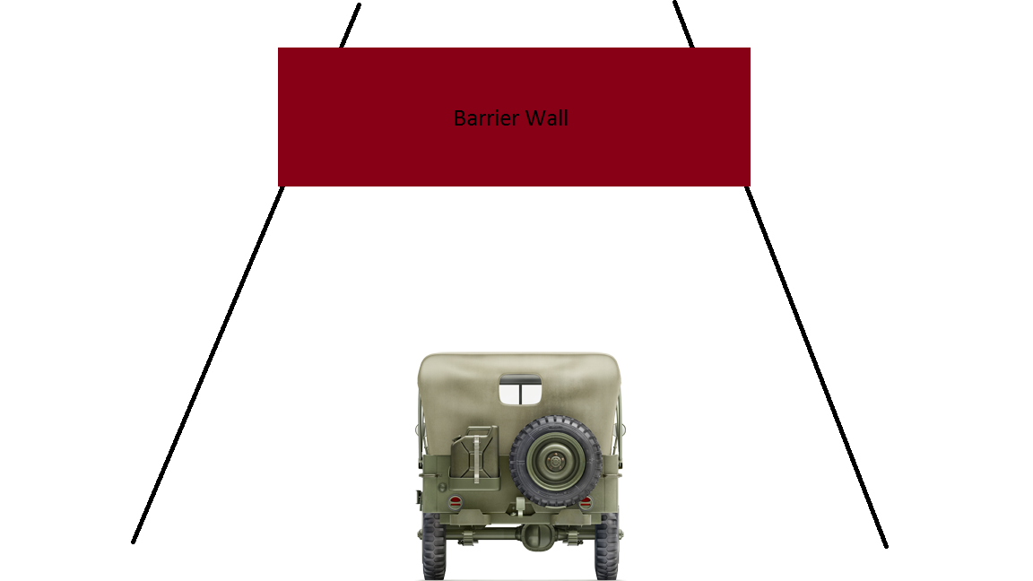

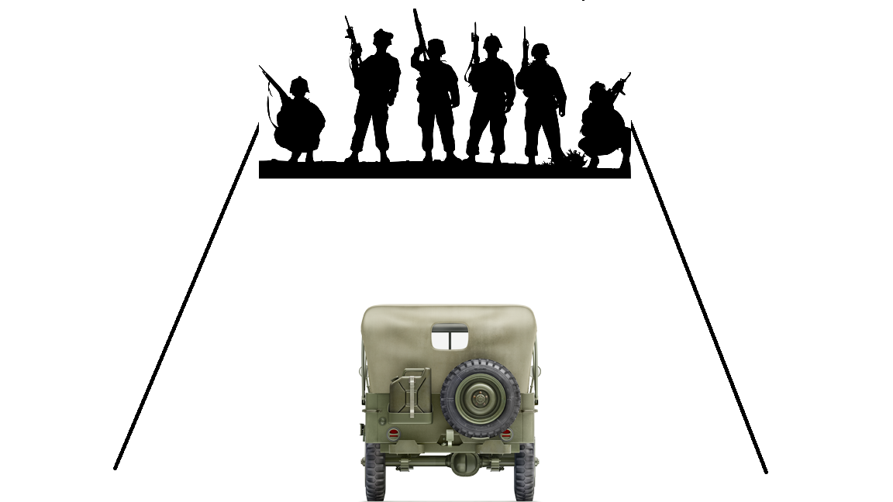

# Menu and Screen Descriptions

**Finish Screen**

If the player destroyed for 5 times, game gets over. Player can play again by pressing try again button.

# Game World

In this diversion, principle foundation is the battlefield. The whole amusement has 3D first person perspective and obstructions in it. Primary symbol is a Military Truck. Player sees everything from the first person view. As the truck goes ahead, it confronts numerous obstructions like mines, barrier walls as impediments particular to every level. Player needs to keep away from all these with a specific end goal to survive and gather the soldiers from the 1 point and bring back to the destination.

# Levels

# Characters/Objects

### Military Truck

The main character or AVATAR in this game is a Military Truck. Player’s main goal is to control the forward, backward, right and left movement of truck with the Up, Down, right and left key on the keyboard to get points by taking truck to the abandoned soldier and bring back home.

# Non-player Characters

### Barrie Wall

Barrier walls are there to stop the player from getting to the soldiers.

# Enemies

### Mines

Mines are there to destroy the military truck.

### Soldiers

Soldier at other point of the game waiting to be rescued.

# Scoring

### Lives

One life gets reduced each time saviour truck get destroyed. Player has 5 lives in starting.

### Scores

100 scores are awarded for each obstacle to cross unharmed.